SPO

Site Creation Wizard Deployment Guide

Version 4.0

Leo Pharma

Document Information

|  |  |
| --- | --- |
| Authors | Brian Jacobsen |
| Status | Final |

History

|  |  |  |  |
| --- | --- | --- | --- |
| Version | Date | Modified by | Changes |
| 0.1 | 26/06-2017 | Brian Jacobsen | Initial Version – v1 deployment |
| 1.0 | 27/06-2017 | Mikael Nilsson | V1.0 |
| 1.1 | 28/06-2017 | Brian Jacobsen | Post Deploy Updates |
| 2.0 | 22/08-2017 | Brian Jacobsen | Updated with SCW Upgrade updates |
| 2.1 | 25/10-2017 | Brian Jacobsen | Updated with SPOR2 elements (Site overview list, External user review) |
| 3.0 | 06/11-2017 | Mikael Nilsson | Baselined |
| 3.1 | 20/11-2017 | Brian Jacobsen | Updated with SPOR3 elements |
| 4.0 | 12/12-2017 | Mikael Nilsson | Baselined |

**Approvals**

|  |  |  |  |  |  |  |  |  |
| --- | --- | --- | --- | --- | --- | --- | --- | --- |
|  | **Authors** |  |  |  |  |  |  |  |
|  | Avanade |  | Brian Jacobsen |  |  |  |  |  |
|  |  |  | Printed name |  | Signature |  | Date |  |
|  |  |  |  |  |  |  |  |  |
|  | **Approval** |  |  |  |  |  |  |  |
|  |  |  |  |  |  |  |  |  |
|  | SDM |  | Mia Praestkjaer Lilmoes |  |  |  |  |  |
|  |  |  | Printed name |  | Signature |  | Date |  |
|  |  |  |  |  |  |  |  |  |
|  | Avanade Project Manager |  | Mikael Nilsson |  |  |  |  |  |
|  |  |  | Printed name |  | Signature |  | Date |  |
|  |  |  |  |  |  |  |  |  |

Contents

1 Overview 6

1.1 Pre-requisites 6

1.2 References 7

2 Site Creation Wizard 8

2.1 Overview 8

2.2 Configuration 8

2.2.1 Installation steps 8

2.2.2 SharePoint Online setup 8

2.2.3 SharePoint Frontend App Configuration 9

2.2.4 Register App Principal 10

2.2.5 Backend Services Setup (Azure) 12

2.2.6 Site Request Workflow 13

2.3 Uninstallation steps 14

3 Site Overview List 15

3.1 Overview 15

3.2 Prerequisites 15

3.3 Configuration 15

3.3.1 Installation steps 15

3.3.2 SiteOverviewList Creation 15

3.3.3 Governance REST Service (Azure) 16

3.3.4 Flow: ExternalUserReview-AddItemToSiteOverviewList 16

3.4 Addition of current site collections 18

3.5 Uninstallation steps 18

4 External User Review 19

4.1 Overview 19

4.2 Prerequisites 19

4.3 Configuration 19

4.3.1 Installation steps 19

4.3.2 Flow: ExternalUserReview-StartExternalUserReview 19

4.3.3 Flow: ExternalUserReview-ExternalReviewRequest 21

4.4 Uninstallation steps 22

5 Site Retention Review 23

5.1 Overview 23

5.2 Prerequisites 23

5.3 Configuration 23

5.3.1 Installation steps 23

5.3.2 Flow: SiteRetentionReview-StartSiteRetentionReview 23

5.3.3 Flow: SiteRetentionReview-SiteRetentionReviewRequest 25

5.4 Uninstallation steps 26

# Overview

This document describes administrative tasks that Leo Pharma administrators need to do to deploy the Site Creation Wizard to Azure and Office 365.

## Pre-requisites

Below is the list of prerequisites to deploy the solution:

|  |  |
| --- | --- |
| Resource name | Description |
| Access to Azure subscription | To deploy Web app and set application and log settings |
| App Catalog | The SharePoint App Catalog must be available |
| Azure PowerShell | Available from:  <https://www.microsoft.com/web/downloads/platform.aspx>  <https://docs.microsoft.com/en-us/powershell/azure/install-azurerm-ps?view=azurermps-4.1.0> |
| Azure Web Job | An Azure WebJob is created |
| Service account with E1/3 license | A service account which must be SPO Administrator and have a valid email address associated |
| Office 365 tenant administrator permissions | The user deploying must be a SharePoint Online Administrator |
| Patterns and Practices PowerShell module | Download the Microsoft Patterns and Practices PowerShell module from <https://github.com/officedev/pnp-powershell/releases> and install it on the client workstation from where the installation is performed (SharePointPnPPowerShellOnline.msi) |
| SharePoint Designer 2013 SP1 | SharePoint Designer 2013 SP1 needs to be installed to local machine to add simple workflows to lists or libraries. The tool can be downloaded from here:  <https://www.microsoft.com/en-us/download/details.aspx?id=35491>  If Visual Studio 2015 is installed, install this hotfix: <https://support.microsoft.com/en-us/kb/3114337>  Note .NET Framework v3 is required for Workflow Elements  Note that if there are issues with being requested to restart SharePoint Designer constantly, then close SPD, remove the below folders and restart SPD   * <user profile>\appdata\roaming\microsoft\SharePoint Designer\ProxyAssemblyCache * <user profile>\appdata\local\microsoft\websitecache\<sitename> |
| Site collection | To deploy Add-in, configuration lists and libraries and upload templates and other files |
| Flow License | All users participating in approvals must have a Flow license assigned (E3 Flow License will suffice) |

## References

This is a list of references that will be used within this document:

LEO Pharma Test Implementation

|  |  |  |
| --- | --- | --- |
| Name | Production | Test/QA |
| Azure Portal | <https://portal.azure.com/> | <https://portal.azure.com/> |
| Azure Resource Group | See App CIL | See App CIL |
| Azure Service Plan | See App CIL | See App CIL |
| Azure App Insights | See App CIL | See App CIL |
| Azure Web App Domain | See App CIL | See App CIL |
| Azure Web App Name | See App CIL | See App CIL |
| Azure Web Job Name | See App CIL | See App CIL |
| AuthenticationPassword | See App CIL | See App CIL |
| AuthenticationUser | See App CIL | See App CIL |
| SPO Admin Portal | <https://leopharma-admin.sharepoint.com> | <https://leopharmatest-admin.sharepoint.com> |
| SPO App Catalog | <https://leopharma.sharepoint.com/sites/appcatalog> | <https://leopharmatest.sharepoint.com/sites/appcatalog> |
| SPO Portal | <https://portal.office.com> | <https://portal.office.com> |
| SPO Self Service Portal | See App CIL | See App CIL |
| SPO Tenant Name | leopharma | leopharmatest |
| Subscription ID | See App CIL | See App CIL |
| Preshared Key | See App CIL | See App CIL |
| EventReceiverurl | See App CIL | See App CIL |
| ClientID | See App CIL | See App CIL |
| ClientSecret | See App CIL | See App CIL |
| GovernanceWebApp | See App CIL | See App CIL |
| EventReceiverurlGov | See App CIL | See App CIL |
| NotifyMessageRejected | See App CIL | See App CIL |
| NotifyMessageNoResponse | See App CIL | See App CIL |
| NotifyMessageRejectedHeader | See App CIL | See App CIL |
| NotifyMessageNoResponseHeader | See App CIL | See App CIL |
| FlowAccount | See App CIL | See App CIL |
| GovWebAppUrl | See App CIL | See App CIL |
| GovPresharedKey | See App CIL | See App CIL |

# Site Creation Wizard

## Overview

This chapter outlines the tasks to install and configure the Site Creation Wizard frontend and backend functionalities.

## Configuration

### Installation steps

The deployment package contains a number of files, as outlined below.

* Frontend – Elements located in Office 365 (Supporting lists + frontend)
* Backend – Backend located in Azure

### SharePoint Online setup

The installation steps for the frontend elements are:

* Go to the SharePoint admin center <REF: SPO Admin Portal> as a SharePoint Online Service Administrator or Office 365 Global Administrator account
* Verify your PowerShell and Module versions

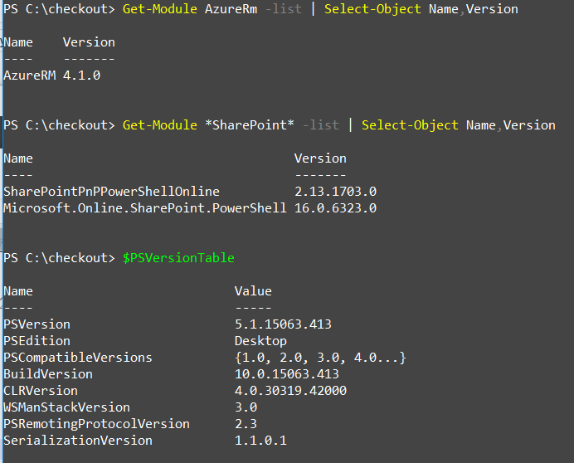

* Change directory to the frontend folder
* Execute the script Frontend\01-CreateSite.ps1
* Execute the script Frontend\02-DeployPackage.ps1
* Update the site collection administrators to appropriate users, as per App CIL

### SharePoint Frontend App Configuration

Execute the following steps to install the frontend webpart

* Open a browser as either a SharePoint Online Administrator or a Global Administrator
* Browse to the app catalog
  + <REF: SPO App Catalog >/AppCatalog/Forms/AllItems.aspx
* Drag the frontend\scw.sppkg package into the “Apps for SharePoint” library
* Select “Trust It” in the trust dialog
* Browse to the site containing the site creation wizard and select the “Site Contents” reference in the settings dropdown
  + <REF: SPO Self Service Portal >/_layouts/viewlsts.aspx
* In the “New” dropdown dialog, select “App”
* Select the "SiteCreationWizard Frontend” app
* When it’s fully deployed add the web part to the page page where it is to be located (takes a few minutes)
  + The web part is located in the “LEO Pharma” group and is called “Site Creation Wizard”
* Update the web part properties with the preshared key <REF: Preshared Key>
* If the web part shall be used in a dialog page, then add an HTML forms webpart below the site creation wizard frontend
  + Enter the following in the web part properties source editor

<script src="/_layouts/SP.UI.Dialog.js" type="text/javascript"></script>

* + Set the chrome to “None”
* Browse to the SCWConfiguration list in the site
  + <REF: SPO Self Service Portal >/Lists/SCWConfiguration/AllItems.aspx
  + Update the configurations according to the App CIL
* Browse to the SCWSiteTemplates list in the site
  + <REF: SPO Self Service Portal >/Lists/SCWSiteTemplates/AllItems.aspx
  + Add the available templates as per the App CIL
* Upload the appropriate template data to the SCWSiteTemplateData library
  + <REF: SPO Self Service Portal >/Lists/SCWSiteTemplateData/AllItems.aspx
  + Samples are included in the package in pnptemlpate\.

### Register App Principal

It is a prerequisite to register an app identity for executing the backend services

* Open the application registration page in SharePoint Online app catalog site
  + <REF: SPO App Catalog>/_layouts/15/appregnew.aspx
* Select Generate at the Client Id
* Select Generate at the Client Secret
* Enter “<REF: Azure Web App Domain>.azurewebsites.net” as “App Domain”
* Enter “https://<REF: Azure Web App Domain>.azurewebsites.net” as “Redirect Url”
* Select Create

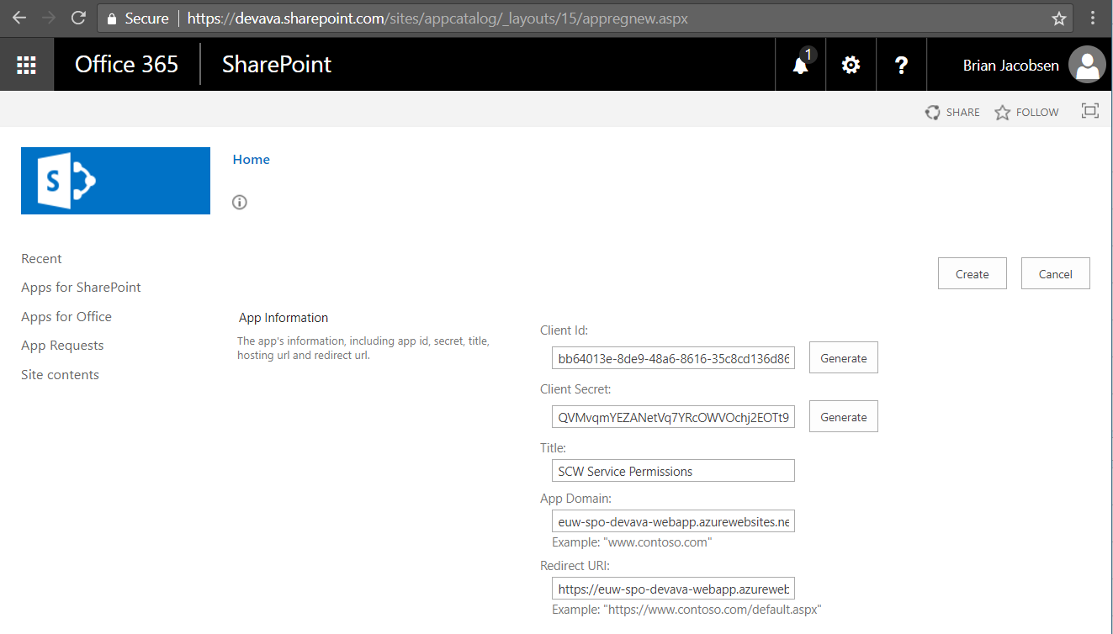

* Copy the output from the creation to a text file (this will be needed later)

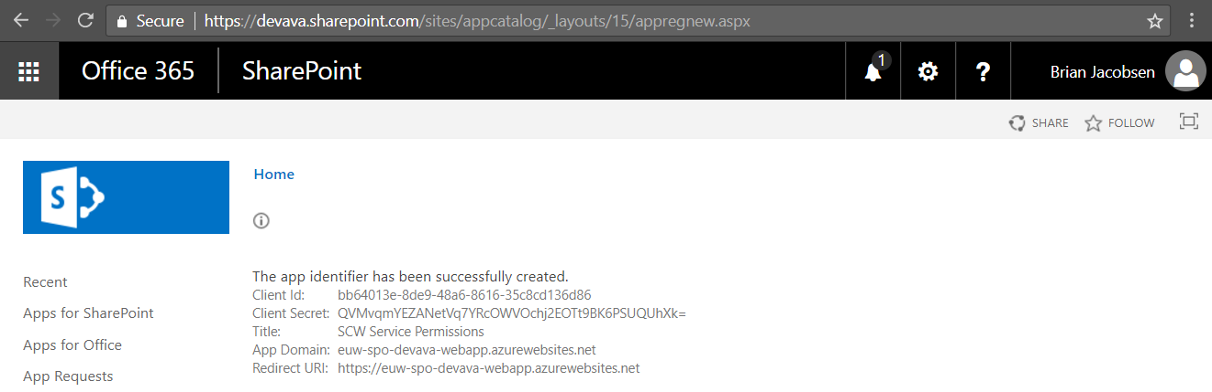

* Update the CIL with the following entries
  + Client ID -> <REF: ClientID>
  + Client Secret -> <REF: ClientSecret>
* Open <REF: SPO Admin Portal>/_layouts/15/appinv.aspx
* Enter the ClientID just created in the “App Id” field, and select Lookup
* Enter the below XML in the App Permissions Request XML

|  |
| --- |
| <AppPermissionRequests AllowAppOnlyPolicy="true">  <AppPermissionRequest Scope="http://sharepoint/content/tenant" Right="FullControl" />  <AppPermissionRequest Scope="http://sharepoint/content/sitecollection/web" Right="FullControl" />  <AppPermissionRequest Scope="http://sharepoint/taxonomy" Right="Read" />  <AppPermissionRequest Scope="http://sharepoint/search" Right="QueryAsUserIgnoreAppPrincipal" />  <AppPermissionRequest Scope="http://sharepoint/content/sitecollection" Right="FullControl" />  </AppPermissionRequests> |

* Select Create

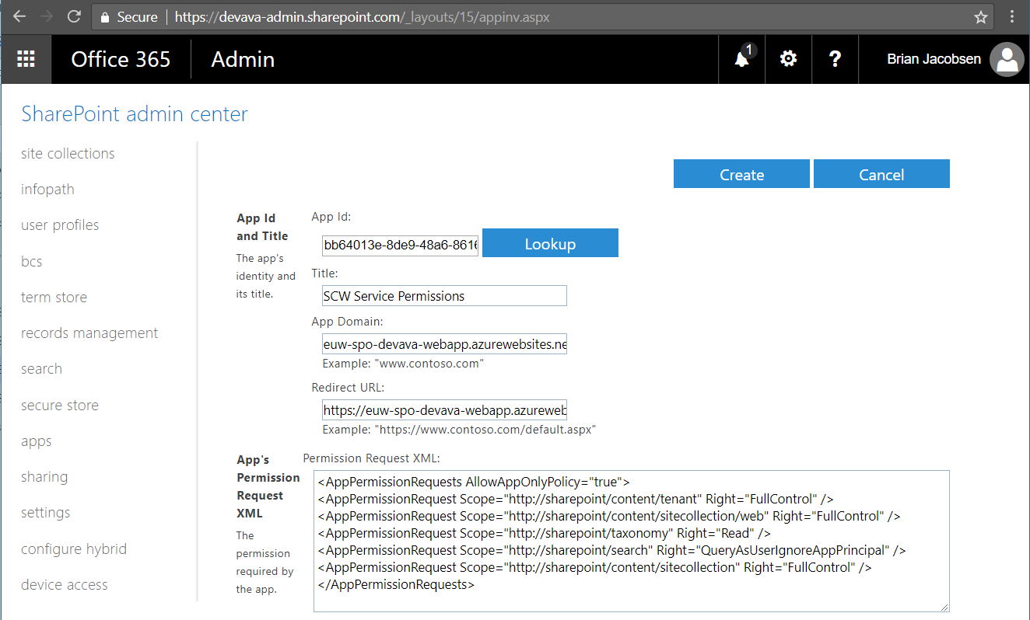

* Select “Trust It”

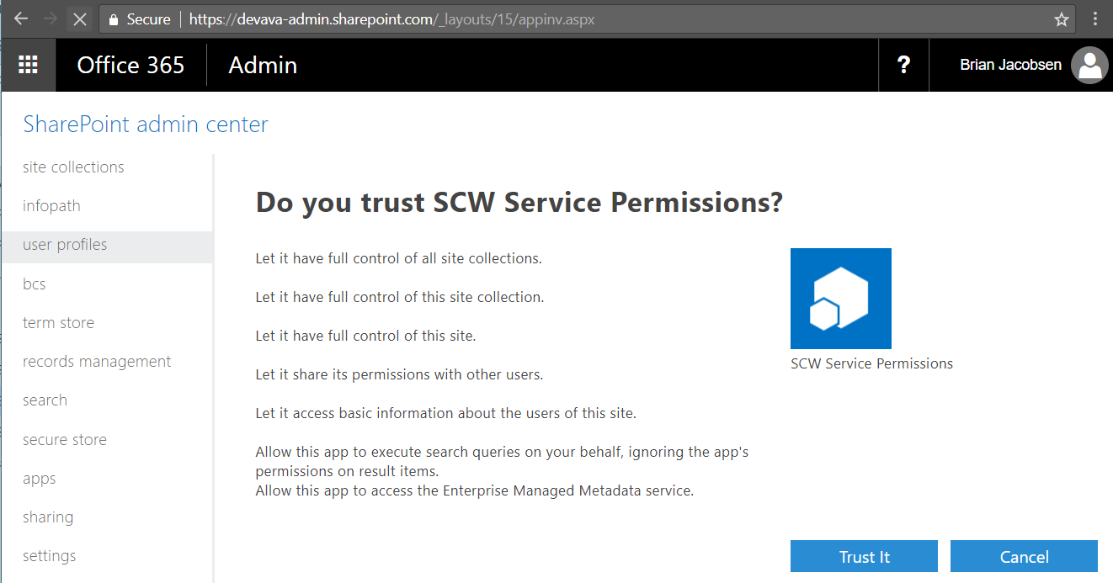

The steps to extend the clientsecret lifespan from the standard 1 year to 3 years are to execute the following PowerShell script, where $id must be set to the <REF: ClientID> created in the previous step and $creds must be set to an Office 365 global admin account

* **IMPORTANT**: Update <REF: ClientSecret> with the new updated client secret (will be displayed in the last write-host command) – this must be used in the rest of the guide.

|  |
| --- |
| $id = new-object System.Guid("GUIDVALUE")  $creds = Get-Credential username@domain.com  Connect-MsolService -Credential $creds  Get-MsolServicePrincipal -AppPrincipalId $id | fl  Get-MsolServicePrincipalCredential -AppPrincipalId $id -ReturnKeyValues $false  $bytes = New-Object Byte[] 32  $rand = [System.Security.Cryptography.RandomNumberGenerator]::Create()  $rand.GetBytes($bytes)  $rand.Dispose()  $newsecret = [System.Convert]::ToBase64String($bytes)  $vf = [System.DateTime]::Now  $vto = $vf.AddYears(3)  New-MsolServicePrincipalCredential -AppPrincipalId $id -Type Symmetric -Usage Sign -Value $newsecret -StartDate $vf -EndDate $vto  New-MsolServicePrincipalCredential -AppPrincipalId $id -Type Symmetric -Usage Verify -Value $newsecret -StartDate $vf -EndDate $vto  New-MsolServicePrincipalCredential -AppPrincipalId $id -Type Password -Usage Verify -Value $newsecret -StartDate $vf -EndDate $vto  Connect-MsolService -Credential $creds  Get-MsolServicePrincipal -AppPrincipalId $id | fl  Get-MsolServicePrincipalCredential -AppPrincipalId $id -ReturnKeyValues $false  Write-Host "Updated ClientSecret - STORE THIS -> [$($newsecret)]" |

### Backend Services Setup (Azure)

The steps to install the Azure elements are:

* Open an Azure PowerShell prompt
* Verify your modules versions



* Update the below settings in deploy.ps1

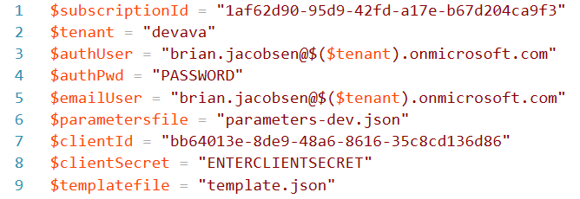

* If the site is already deployed, please remove the current web application from Azure before deploying <REF: Azure Web App Name>, otherwise the MSDeploy will not update the site
* Change directory to the backend\scripts folder
* Execute the deploy.ps1 script
* Enter the Azure account used for deployment in the authentication popup
* After deployment, the Azure resources have been configured

The app settings added to the app service by the above script, are described in the below table:

|  |  |
| --- | --- |
| Parameter | Value |
| SCWHostSite | <REF: SPO Self Service Portal Name > |
| AuthenticationUser | <REF: AuthenticationUser> |
| AuthenticationPassword | <REF: AuthenticationPassword> |
| RootSiteUrl | <REF: RootSiteUrl> |
| SPAdminUrl | <REF: SPO Admin Portal> |
| EmailNewSiteTemplate | EmailTemplateSuccess.html |
| EmailFailureSiteTemplate | EmailTemplateFail.html |
| EmailUserName | <REF: Email From Address> |
| PresharedKey | <REF: Preshared Key> |
| InstrumentationKey | App Insights Instrumentation Key from installation |
| SmtpPort | 587 (don’t change) |
| SmtpHost | smtp.office365.com (don’t change) |
| EventReceiverurl | <REF: EventReceiverurl> |
| ClientID | <REF: ClientID> |
| ClientPassword | <REF: ClientSecret> |

### Site Request Workflow

These steps are required to activate the site requests workflow

* Go to <REF: SPO Self Service Portal>
  + Click on the Gear icon and then click “Site settings”
  + Under “Web Designer Galleries” select “Solutions”
    - From the Ribbon select “Upload Solution”
    - From the popup, select the file “Frontend\Approval Workflow.wsp” and click “OK”
    - From the popup, select “Activate”
  + Package is now activated
* Provision workflow to list:
  + Click on the Gear icon and then click “Site settings”
  + Under Site Actions, select “Manage site features”
  + Active the Workflow template “Approval Workflow” from web template “Collaboration Portal” feature
* Open SharePoint Designer 2013 SP1 (run as administrator) and open the portal
  + <REF: SPO Self Service Portal>
  + Click “Workflows” in the left navigation
    - Select the Approval Workflow
    - Ensure that Task List and History List are selected
      * If not selected, either select an existing or create a new
    - Ensure that the checkmark is checked at
      * Allow this workflow to be manually started
      * Start workflow automatically when an item is created
    - Ensure that the checkmark is unselected at
      * Start workflow automatically when an item is changed
    - Click “Save” from the ribbon
    - Click “Publish” from the ribbon

## Uninstallation steps

This chapter is for removing the solution. It involves removing the Azure Resource Group and removing the site creation wizard site collection.

The removal steps are:

* Delete the site creation wizard site collection in the SharePoint Online Admin portal
  + <REF: SPO Portal>
* Browse to the app catalog
  + <REF: SPO App Catalog >/AppCatalog/Forms/AllItems.aspx
* Delete the scw.sppkg package
* Delete the Azure resource group in the Azure Admin Portal
  + <REF: Azure Resource Group>
  + <REF: Azure Portal>

# Site Overview List

## Overview

This chapter outlines the tasks to create the site overview list, deploying the LEO Governance REST services to Azure and configure the Microsoft Flow which will add elements from the site request list.

## Prerequisites

The Site Creation Wizard must be deployed prior to the deployment of this

* Site columns are reused
* The SCWSiteRequests list is required
* The SCW App Principal is reused for the Governance REST Service
  + <REF: ClientID>
  + <REF: ClientSecret>
* The <REF: FlowAccount> must have a Microsoft Flow license assigned
* The <REF: FlowAccount> must have a minimum of Site Owner permissions in the <REF: SPO Self Service Portal Name> site

Verify that the PowerShell prompt is minimum PowerShell v5 and have The SharePoint PnP Online PowerShell module installed.



## Configuration

### Installation steps

The deployment package contains 3 folders:

* 01-RESTService (LEO Governance REST Service deployed to Azure)
* 02-SiteOverviewList (Microsoft PnP provisioning framework template with the SharePoint List)
* 03-MicrosoftFlows (Microsoft Flow Workflows)

### SiteOverviewList Creation

The installation steps for the frontend elements are:

* All authentication must be performed as an administrative user with a minimum of site collection admin permissions in the site collection.
* Change directory to the “02-SiteOverviewList” folder
  + Execute the script .\01-CreateSiteOverviewList-PROD.ps1

### Governance REST Service (Azure)

The steps to install the Azure elements are:

* Open an Azure PowerShell prompt
* If the site is already deployed, please remove the current web application from Azure before deploying <REF: GovernanceWebApp>, otherwise the MSDeploy will not update the site
* Ensure an app principal has been created, and the clientid + clientsecret have been updated in the Application CIL
  + See chapter **Error! Reference source not found.** (**Error! Reference source not found.**)
* Change directory to the deployment package folder
* Change directory to the “01-RESTService” folder
  + Update the script .\01-DeployPROD.ps1 with the appropriate settings for the environment

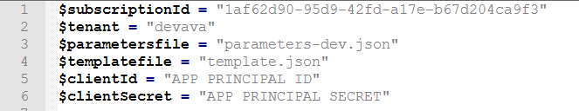

* + Execute the script .\01-DeployPROD.ps1
  + Enter the Azure account used for deployment in the authentication popup
* After deployment, the Azure resources have been configured

The app settings added to the app service by the above script, are described in the below table:

|  |  |
| --- | --- |
| Parameter | Value |
| PresharedKey | <REF: GovPresharedKey> |
| ClientID | <REF: ClientID> |
| ClientPassword | <REF: ClientSecret> |
| InstrumentationKey | App Insights Instrumentation Key from installation |
| SPAdminUrl | <REF: SPO Admin Portal> |
| SCWHostSite | <REF: SPO Self Service Portal Name> |
| EventReceiverUrl | <REF: EventReceiverurlGov> |
| NotifyMessageRejected | <REF: NotifyMessageRejected> |
| NotifyMessageNoResponse | <REF: NotifyMessageNoResponse> |
| NotifyMessageRejectedHeader | <REF: NotifyMessageRejectedHeader> |
| NotifyMessageNoResponseHeader | <REF: NotifyMessageNoResponseHeader> |
| FlowAccount | <REF: FlowAccount> |

### Flow: ExternalUserReview-AddItemToSiteOverviewList

The steps required to install the Microsoft Flow are:

* Start a PowerShell prompt
* Change directory to the “03-MicrosoftFlows” folder
* Execute the 01-GetFlows-PROD.ps1 script
* Enter the credentials <REF: FlowAccount> for the <REF: SPO Self Service Portal Name> site to extract list id’s

Log into the <REF: SPO Self Service Portal Name> site as the <REF: FlowAccount> account.

* Open the SCWSiteRequests list
* Select “See your flows”

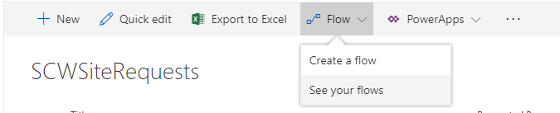

* Select “Import”



* Upload the “ExternalUserReview-AddItemToSiteOverviewList-<ENV>.zip” file

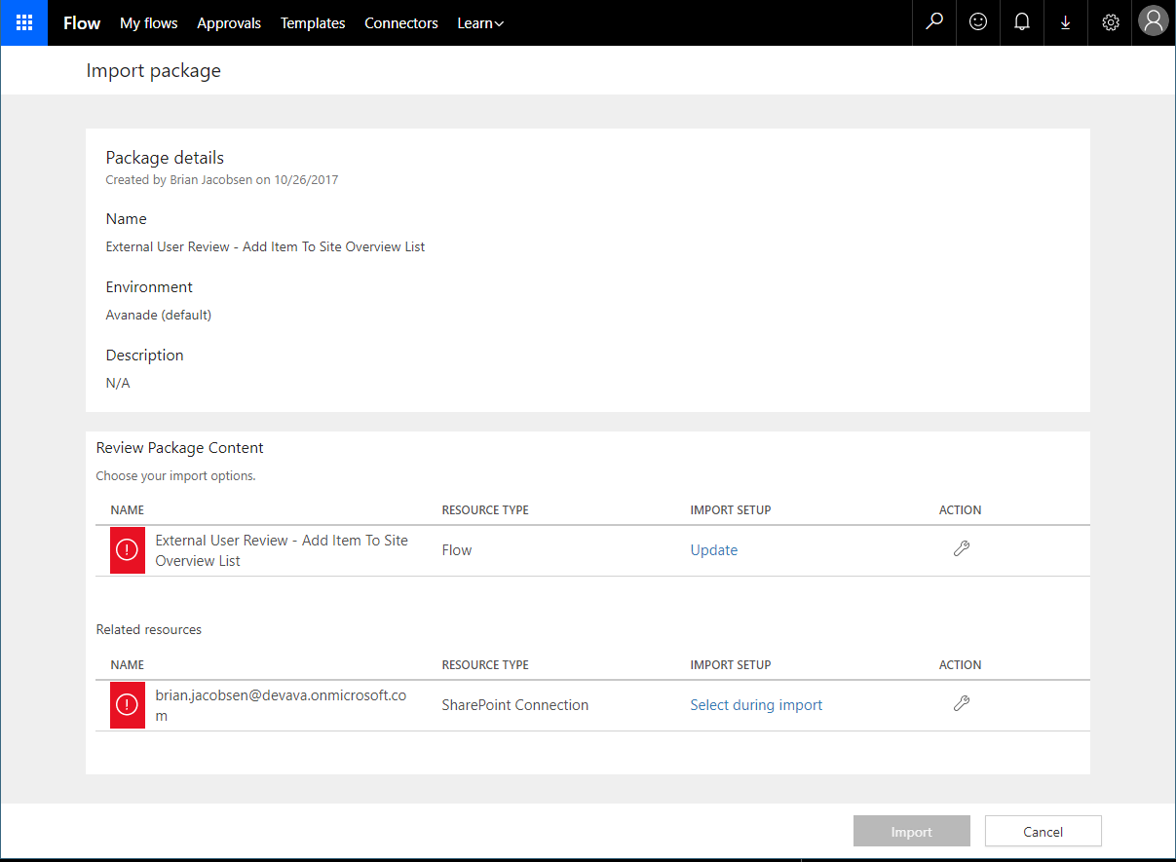

* If this a new import and not an update import, select the  icon in the import options action
* Change the setup type to “Create as new” and select “Save”

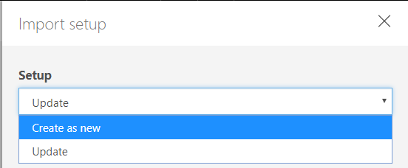

* Select the  icon in the related resources action
* If the correct connection account is listed <REF: FlowAccount>, select the connection + “Save”
* If the correct connection account is not listed, then create a new connection with the <REF: FlowAccount> account, select it + “Save”
* Select “Import”
* Select “Open flow”



* If the connection needs to be updated (e.g. password change or an expired refresh token), select “Fix” and fix the error (refresh the page with the flow afterwards to ensure the updated connections are depicted)

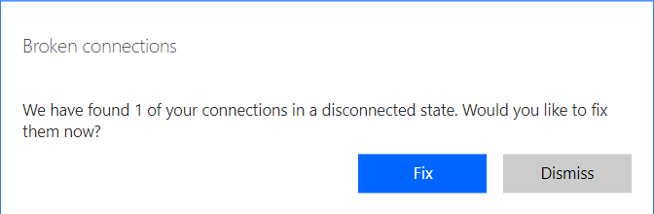

* Select “Update Flow”



* Select “Done”



## Addition of current site collections

Current site collections can be added into the SiteOverviewList through Excel in the QuickEdit functionality, note that this must be done in Internet Explorer 11+ (not supported in Chrome).

Note that the addition of these will not result in any workflows being started, only the scheduled “Start External User Review” workflow will start new workflows.

## Uninstallation steps

This chapter outlines the tasks required for removing the site overview list.

The following functionalities must be removed prior to removing the SiteOverviewList:

* External User Review (see chapter 4)
* Site Retention Review (see chapter 5)

The removal steps are:

* In the <REF: SPO Self Service Portal> site: Remove the Microsoft Flow workflow “Add Item To Site Overview List” associated with the SiteOverviewList (in context of the <REF: AuthenticationUser> account)
* In the <REF: SPO Self Service Portal> site: Delete the list called “SiteOverviewList”

# External User Review

## Overview

This chapter outlines the tasks to add the workflows utilized by the External User Review functionality.

## Prerequisites

The Site Creation Wizard (see chapter 2 - Site Creation Wizard) must be deployed.

The Site Overview List (see chapter 3 - Site Overview List) must be deployed.

Verify that the PowerShell prompt is minimum PowerShell v5 and have The SharePoint PnP Online PowerShell module installed.



A service account is required (<REF: FlowAccount>), which will be used for executing the flows and update the item in the SiteOverviewList, note as this account is the sender of approval requests and notifications, it is recommended to name the account displayname appropriately and add an appropriate image as the account userphoto (SharePoint User Profile).

This account must be a site owner of the <REF: SPO Self Service Portal> site, and have a minimum of the following licenses assigned (All can be from the standard LEO Pharma E3 license):

* Exchange Online
* SharePoint Online
* Microsoft Flow

## Configuration

### Installation steps

The deployment package contains 3 folders:

* 01-RESTService (LEO Governance REST Service deployed to Azure)
* 02-SiteOverviewList (Microsoft PnP provisioning framework template with the SharePoint List)
* 03-MicrosoftFlows (Microsoft Flow Workflows)

This chapter utilizes elements from the “03-MicrosoftFlows” folder.

### Flow: ExternalUserReview-StartExternalUserReview

The steps required to install the Microsoft Flow are:

* Start a PowerShell prompt
* Change directory to the “03-MicrosoftFlows” folder
* If the 01-GetFlows-<ENV>.ps1 script hasn’t been executed then execute the following steps
  + Execute the 01-GetFlows-PROD.ps1 script
  + Enter the credentials <REF: FlowAccount> for the <REF: SPO Self Service Portal Name> site to extract list id’s

Log into the <REF: SPO Self Service Portal Name> site as the <REF: FlowAccount> account.

* Open the “SiteOverviewList” list
* Select “See your flows”

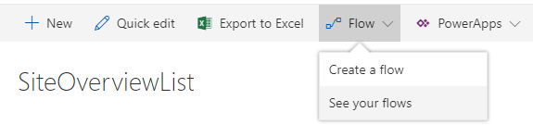

* Select “Import”



* Upload the “ExternalUserReview-StartExternalUserReview-<ENV>.zip” file

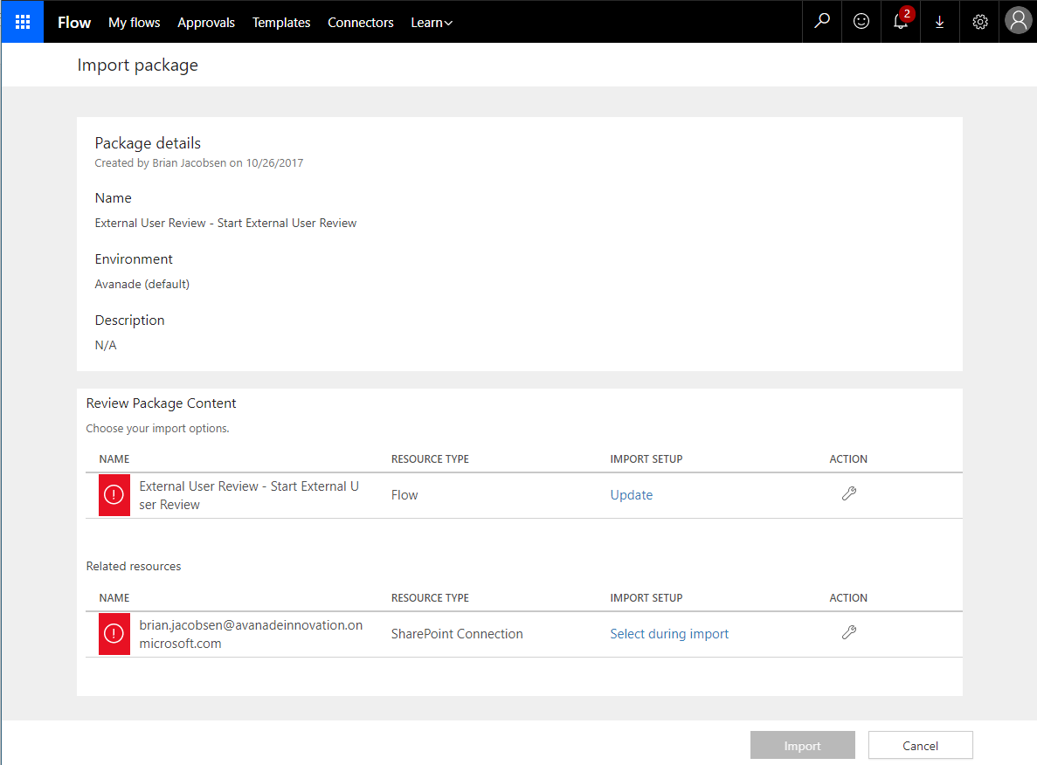

* If this a new import and not an update import, select the  icon in the import options action
* Change the setup type to “Create as new” and select “Save”



* Select the  icon in the related resources action
* If the correct connection account is listed <REF: FlowAccount>, select the connection + “Save”
* If the correct connection account is not listed, then create a new connection with the <REF: FlowAccount> account, select it + “Save”
* Select “Import”
* Select “Open flow”



* Select “Update Flow”



* Select “Done”



### Flow: ExternalUserReview-ExternalReviewRequest

The steps required to install the Microsoft Flow are:

* Start a PowerShell prompt
* Change directory to the “03-MicrosoftFlows” folder
* If the 01-GetFlows-<ENV>.ps1 script hasn’t been executed then execute the following steps
  + Execute the 01-GetFlows-PROD.ps1 script
  + Enter the credentials <REF: FlowAccount> for the <REF: SPO Self Service Portal Name> site to extract list id’s

Log into the <REF: SPO Self Service Portal Name> site as the <REF: FlowAccount> account.

* Open the “SiteOverviewList” list
* Select “See your flows”



* Select “Import”



* Upload the “ExternalUserReview-ExternalReviewRequest-<ENV>.zip” file

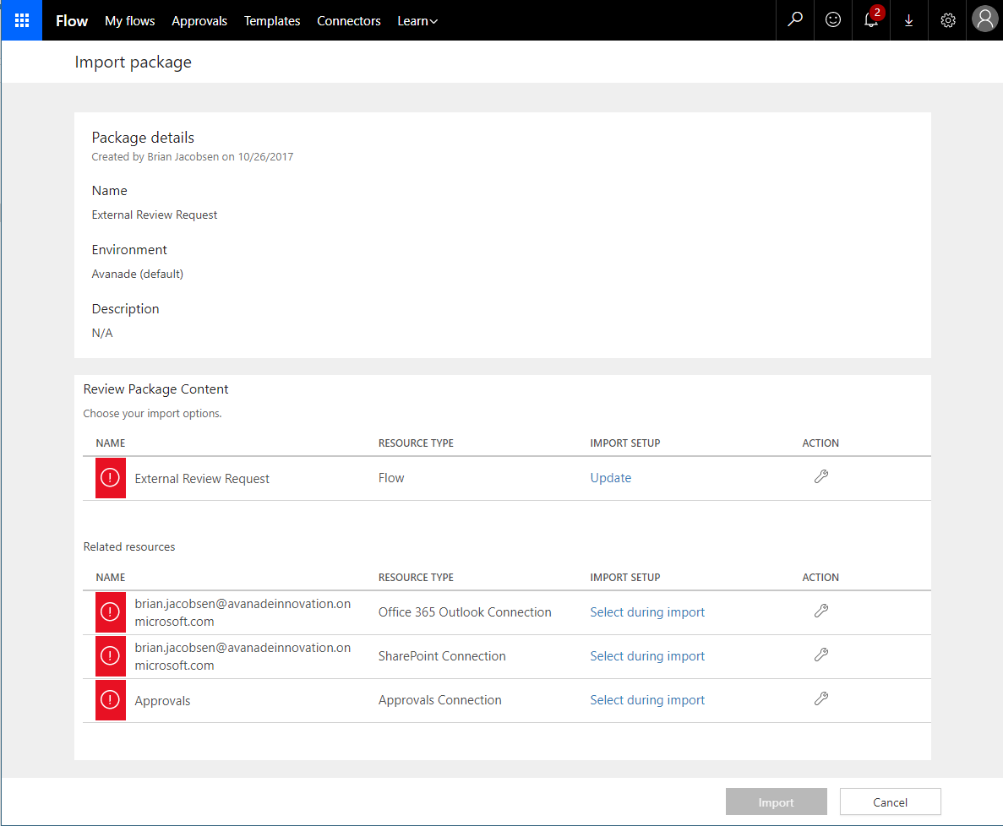

* If this a new import and not an update import, select the  icon in the import options action
* Change the setup type to “Create as new” and select “Save”



* Select the  icon in each of the the related resources action
* If the correct connection account is listed <REF: FlowAccount>, select the connection + “Save”
* If the correct connection account is not listed, then create a new connection with the <REF: FlowAccount> account (or the standard Approvals if it’s the Approvals missing a connection), select it + “Save”
* Select “Import”
* Select “Open flow”



* Select “Update Flow”



* Select “Done”



## Uninstallation steps

This chapter outlines the tasks required for removing the External User Review Flows.

The removal steps are:

* Log into the <REF: SPO Self Service Portal Name> site as the <REF: FlowAccount> account.
* Open the “SiteOverviewList” list
* Select “See your flows”



* Remove the Microsoft Flow workflow “External User Review”
* Remove the Microsoft Flow workflow “Start External User Review”

# Site Retention Review

## Overview

This chapter outlines the tasks to add the workflows utilized by the Site Retention (Lifecycle) Review functionality.

## Prerequisites

The Site Creation Wizard (see chapter 2 - Site Creation Wizard) must be deployed.

The Site Overview List (see chapter 3 - Site Overview List) must be deployed.

Verify that the PowerShell prompt is minimum PowerShell v5 and have The SharePoint PnP Online PowerShell module installed.



A service account is required (<REF: FlowAccount>), which will be used for executing the flows and update the item in the SiteOverviewList, note as this account is the sender of approval requests and notifications, it is recommended to name the account displayname appropriately and add an appropriate image as the account userphoto (SharePoint User Profile).

This account must be a site owner of the <REF: SPO Self Service Portal> site, and have a minimum of the following licenses assigned (All can be from the standard LEO Pharma E3 license):

* Exchange Online
* SharePoint Online
* Microsoft Flow

## Configuration

### Installation steps

The deployment package contains 3 folders:

* 01-RESTService (LEO Governance REST Service deployed to Azure)
* 02-SiteOverviewList (Microsoft PnP provisioning framework template with the SharePoint List)
* 03-MicrosoftFlows (Microsoft Flow Workflows)

This chapter utilizes elements from the “03-MicrosoftFlows” folder.

### Flow: SiteRetentionReview-StartSiteRetentionReview

The steps required to install the Microsoft Flow are:

* Start a PowerShell prompt
* Change directory to the “03-MicrosoftFlows” folder
* If the 01-GetFlows-<ENV>.ps1 script hasn’t been executed then execute the following steps
  + Execute the 01-GetFlows-PROD.ps1 script
  + Enter the credentials <REF: FlowAccount> for the <REF: SPO Self Service Portal Name> site to extract list id’s

Log into the <REF: SPO Self Service Portal Name> site as the <REF: FlowAccount> account.

* Open the “SiteOverviewList” list
* Select “See your flows”



* Select “Import”



* Upload the “SiteRetentionReview-StartSiteRetentionReview-<ENV>.zip” file

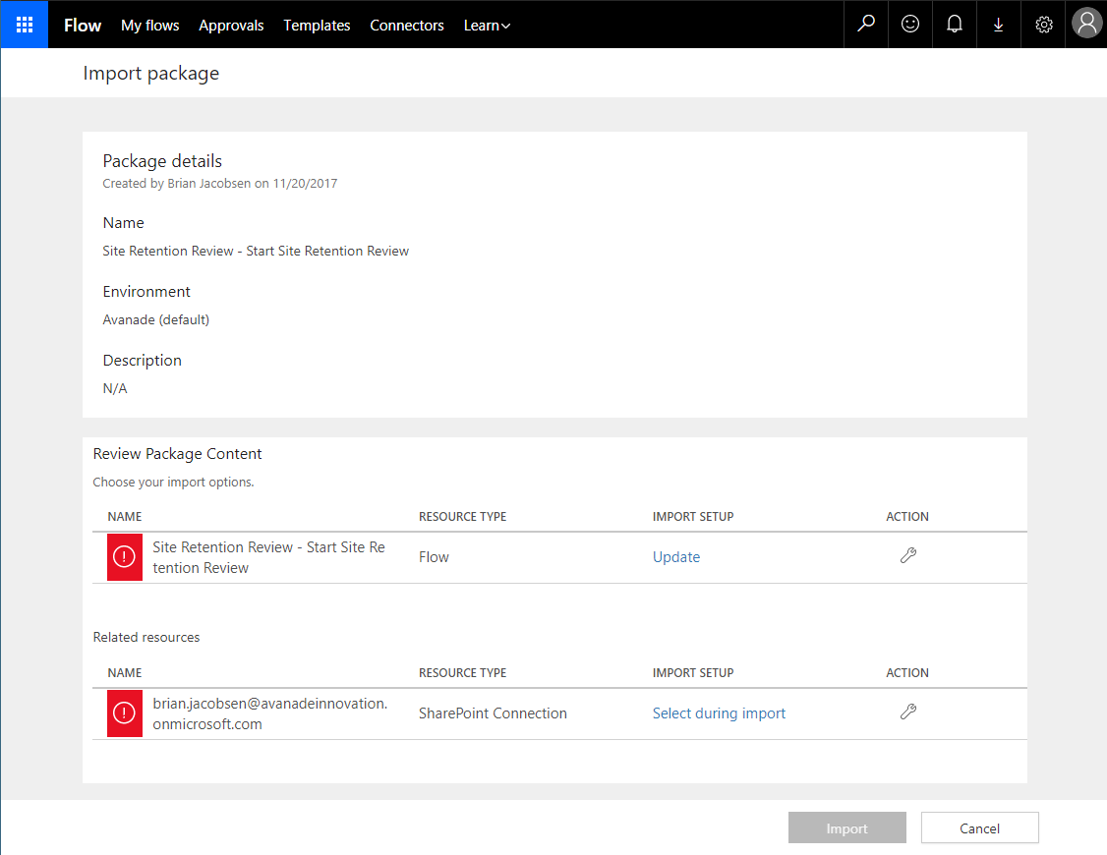

* If this a new import and not an update import, select the  icon in the import options action
* Change the setup type to “Create as new” and select “Save”



* Select the  icon in the related resources action
* If the correct connection account is listed <REF: FlowAccount>, select the connection + “Save”
* If the correct connection account is not listed, then create a new connection with the <REF: FlowAccount> account, select it + “Save”
* Select “Import”
* Select “Open flow”



* Select “Update Flow”



* Select “Done”



### Flow: SiteRetentionReview-SiteRetentionReviewRequest

The steps required to install the Microsoft Flow are:

* Start a PowerShell prompt
* Change directory to the “03-MicrosoftFlows” folder
* If the 01-GetFlows-<ENV>.ps1 script hasn’t been executed then execute the following steps
  + Execute the 01-GetFlows-PROD.ps1 script
  + Enter the credentials <REF: FlowAccount> for the <REF: SPO Self Service Portal Name> site to extract list id’s

Log into the <REF: SPO Self Service Portal Name> site as the <REF: FlowAccount> account.

* Open the “SiteOverviewList” list
* Select “See your flows”



* Select “Import”



* Upload the “SiteRetentionReview-SiteRetentionReviewRequest-<ENV>.zip” file

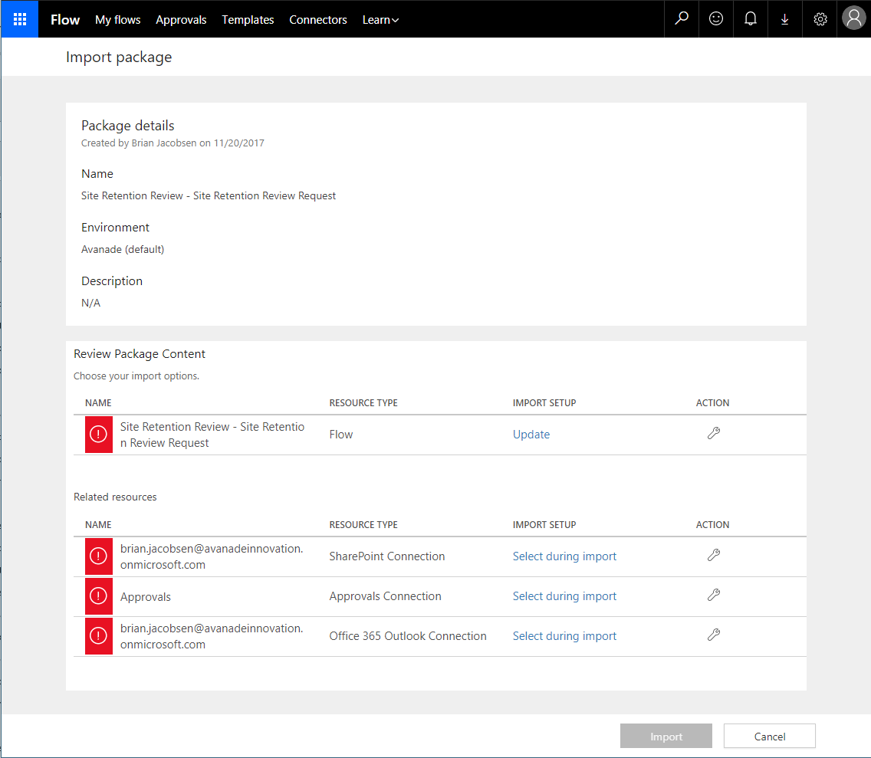

* If this a new import and not an update import, select the  icon in the import options action
* Change the setup type to “Create as new” and select “Save”



* Select the  icon in each of the the related resources action
* If the correct connection account is listed <REF: FlowAccount>, select the connection + “Save”
* If the correct connection account is not listed, then create a new connection with the <REF: FlowAccount> account (or the standard Approvals if it’s the Approvals missing a connection), select it + “Save”
* Select “Import”
* Select “Open flow”



* Select “Update Flow”

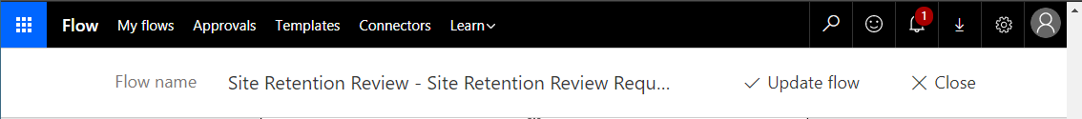

* Select “Done”

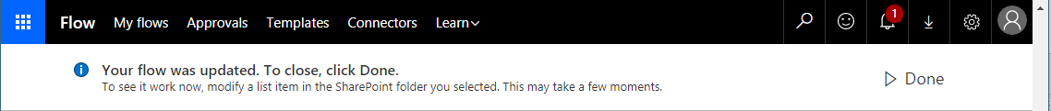

## Uninstallation steps

This chapter outlines the tasks required for removing the External User Review Flows.

The removal steps are:

* Log into the <REF: SPO Self Service Portal Name> site as the <REF: FlowAccount> account.
* Open the “SiteOverviewList” list
* Select “See your flows”



* Remove the Microsoft Flow workflow “Site Retention Review - Site Retention Review Request”
* Remove the Microsoft Flow workflow “Site Retention Review - Start Site Retention Review”